**How to use the MATLAB function**

The MATLAB function name is plotDBCEx.m .

The inputs needed are txt file, dbc file and excel file. The excel file should have the names of signal that needs to plot. Name the signals in first column as like this

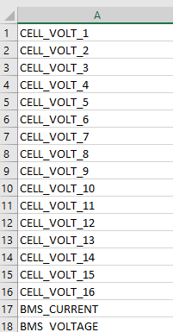

Open the function in MATLAB . The type the function with necessary inputs in command window. Format:- plotDBCEx(txtFile, dbcFile, signalExcelFile). In the place of the name give their path.

Eg:plotDBCEx("C:\Users\Dell\Downloads\efficiencytest2canpro.txt","C:\Users\Dell\Documents\GenericBMS.dbc","C:\Users\Dell\Documents\Book1.xlsx");

Then click the enter then it appears the signal names in the command window and graph in separate windows.

